

**Project Title: POWER PROVISION MANAGEMENT SYSTEM**

Presented By

Kamanzi Keina Ellah

22849

Networks Communication Systems

May,2023

1. **Project requirements:**

This is a web application designed to help big companies like REG and their clients to monitor the distributed electricity provided efficiently. REG would be able to know exactly the power their clients need by knowing all appliances and devices that they will use. The client will be able to know the exact Electric current they will be provided. Therefore, the solution this platform will give is better energy distribution. The limitations are: no voltage levels, power quality and detection of faults/ abnormalities.

1. **Project Plan:**

* Scope of the project: Objectives are, to ease the job of energy companies with the sale and distribution of power and for clients to express their exact need of utility.
* Network Monitoring and Control: The system provides capabilities for monitoring the distribution network in real-time.

1. **Timeline**: 1 week.
2. **Resources**: netbeans , github railway.

**User Guide**

Getting Started:

1. To access the software, just press on this link:=========== https://power-production-a338.up.railway.app/login
2. If you are a new user, click the "Register here" button and fill out the registration form.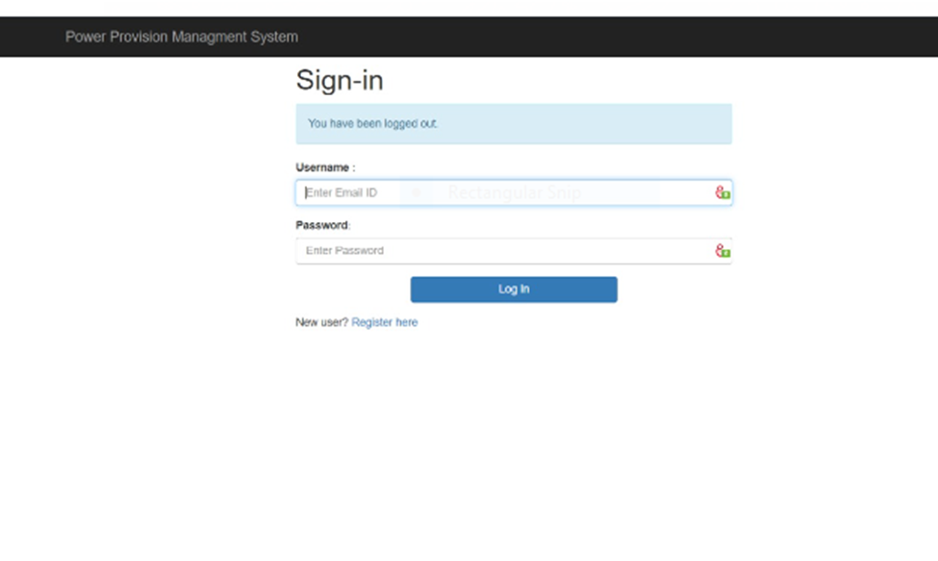
3. Fill in the missing information of this form so as to be created as a new user, then click **login** here and use the same email address and password you just created.

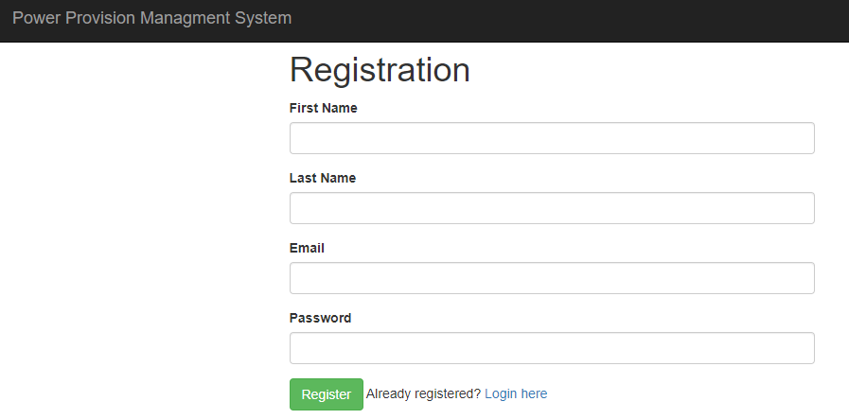

1. After the client logs in here, this is what is displayed.

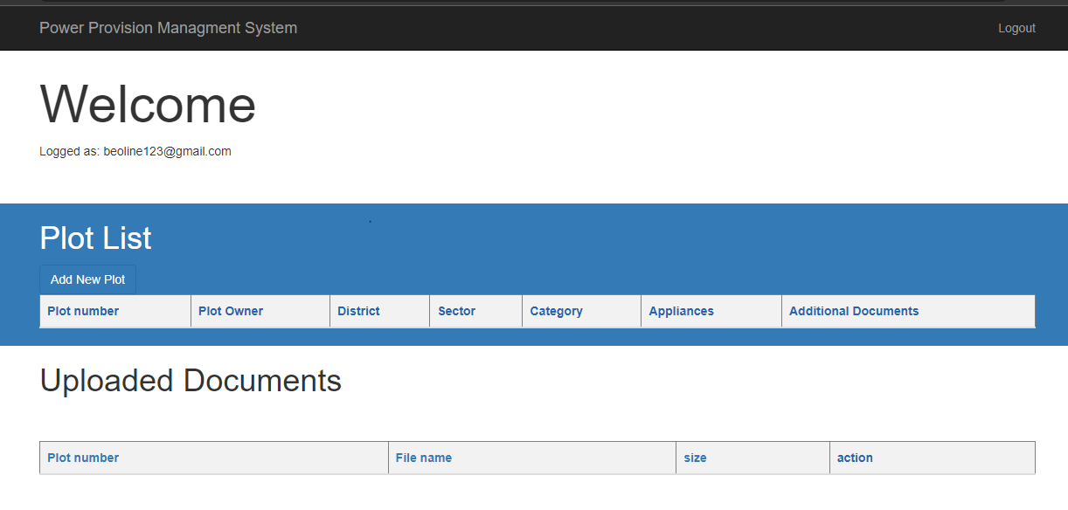

1. The client then clicks on add new plot button and the a form is displayed where he is asked to fill in his address of the plot, including the owner, number (UPI), the category and

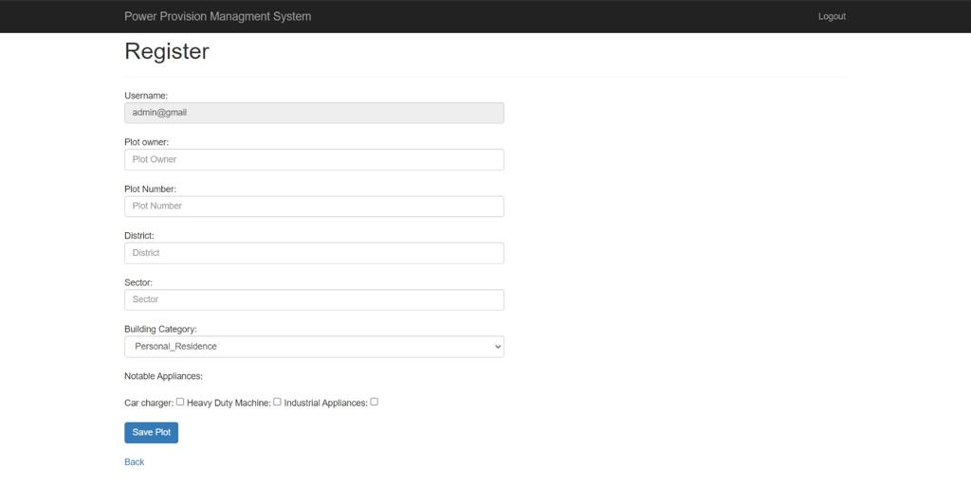

1. After the user clicks save post button he/she he will be notified that he is successfully registered and he/she will click on back to view all details and be able to download the document.

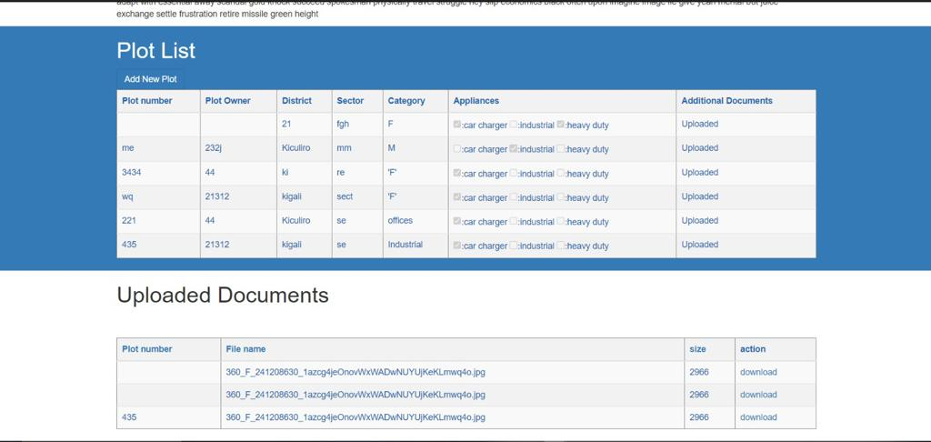

**Admin Guide**

1. The admin is able to view the list of all users that were registered successfully
2. The admin is able to delete a user.
3. The admin is able to download the user’s document.
4. The admin is able to search.

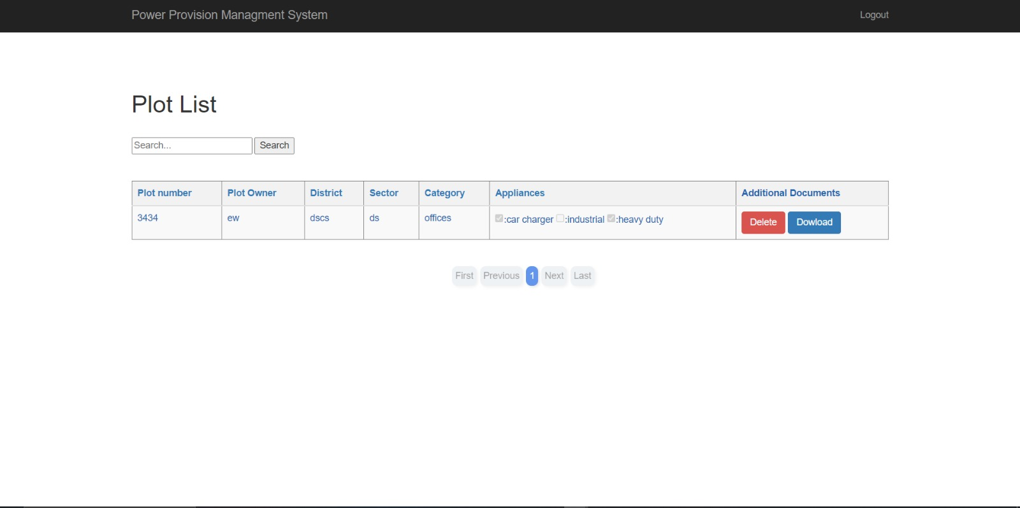

**DATABASE SCHEMA:**

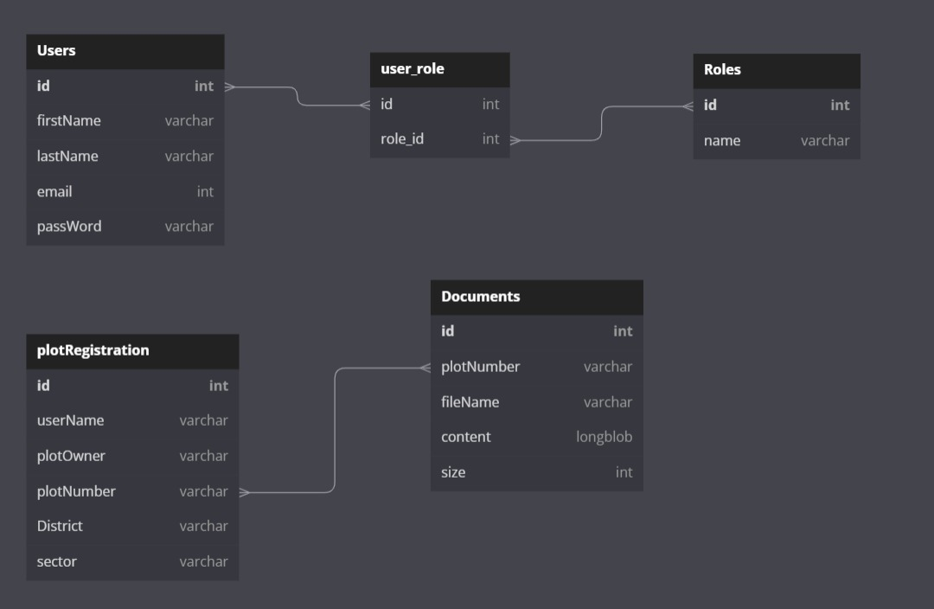

VI. **Technical Documentation**

1. Architecture of the Application: I used Spring MVC and Springboot using thymeleaf.

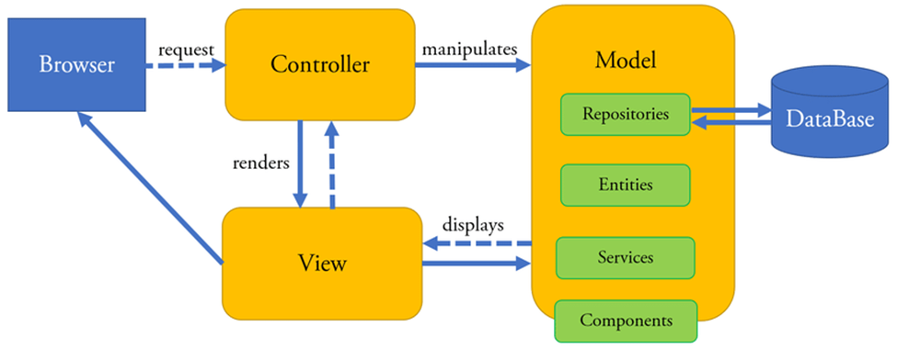

Here are Model (Java classes), View (JSP pages) and Controller (Servlet) of the System:

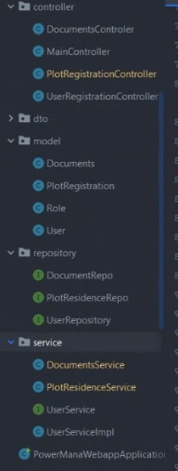

Validation:

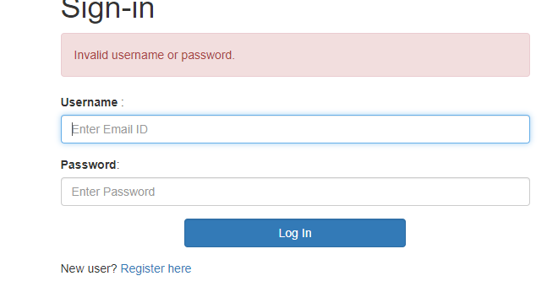

In Conclusion therefore, the solution this platform will give is better energy distribution. The limitations are: no voltage levels, power quality and detection of faults/ abnormalities.